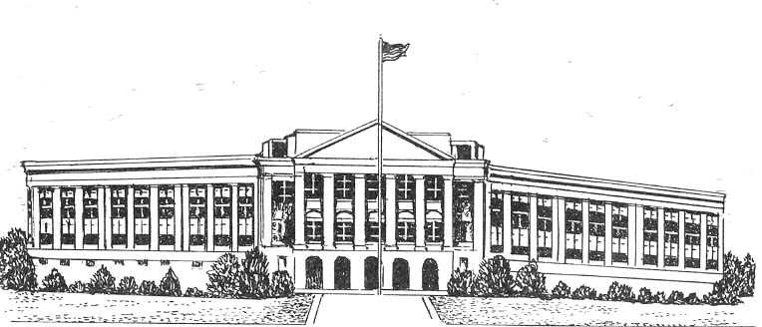
Lake Placid Middle/High School - Summer School

STUDENT REGISTRATION

Monday, June 25 and Tuesday, June 26, 2018
8:00 a.m. - 2:00 p.m. in the Lake Placid Middle/High School Guidance Office

Registration must be completed in person in the Guidance Office at the Lake Placid Middle/High School

PLEASE PRINT

Student Name ______________________________________________ Grade Level __________
Address ________________________________________________________________________
Date of Birth _____________________________________ Male ____ Female ____
Parent/Guardian Name ___________________________________ Home Phone ------
Non-Custodial Parent ____________________________________
Address___________________________________________________________________
Mother’s Work / Cell Phone _______________________ Father’s Work / Cell Phone ___________
Emergency Contact Name: Phone #:

PLEASE CIRCLE OR INITIAL NEXT TO APPROPRIATE COURSES

6th grade English/Social Studies
English 6/7/8 | Science 6/7/8 | Math 6
English 9/10 | Living Environment 1A | Math 7/8
English 11/12 | Living Environment 1B* | Algebra
 | and Biology* | Geometry
Social Studies 7/8 | Chemistry*
Global I | Earth Science* | Economics
Global II |  | Government
U. S. History |  | Health
*Lab requirement must be met for enrollment in this course. Lab completion forms must accompany registration for Chemistry, Living Environment B and Earth Science

Signature on this form certifies that all immunization requirements have been met.

Does this student have an IEP or 504? Yes No (If yes, please provide a copy of the student's IEP/504 and testing modifications).

Date Signature of Principal or Counselor

